***Analysis report on tickers companies and their own price changes.***

1. AAPL (Apple)

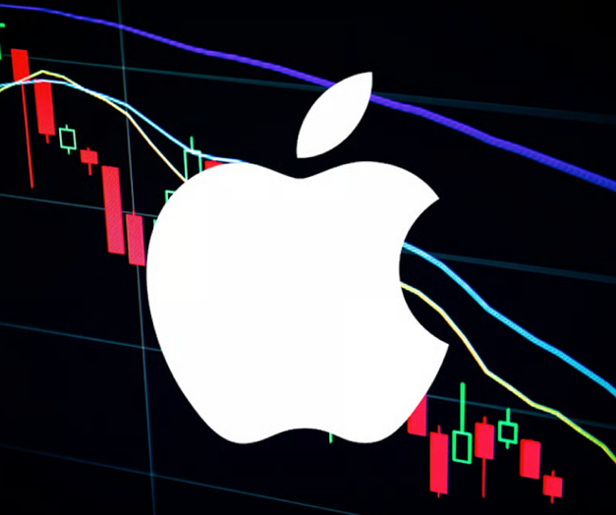

The average stock price was **$196.47**. Headline sentiment averaged **0.04**, and summaries averaged **0.10**, indicating a **generally positive tone**. The stock declined by **-1.13%** compared to the previous day and **-3.68%** over the past 7 days.

The links to the articles:

<https://finance.yahoo.com/news/apple-reroutes-97-foxconn-iphone-013033227.html?.tsrc=rss>

<https://finance.yahoo.com/m/f7444584-01d1-3ff5-b2f9-2327cee6187e/why-superintelligent-ai-isn%E2%80%99t.html?.tsrc=rss>

<https://finance.yahoo.com/news/why-apple-aapl-dipped-more-214502072.html?.tsrc=rss>

1. **AMZN (Amazon):**



The average price was **$212.85**. Sentiments from headlines and summaries were **0.16** and **0.27**, suggesting a **positive tone**. Price remained mostly stable, with a **-0.07%** daily change and **0.13%** over the week.

The links to the articles:

<https://finance.yahoo.com/m/7e78ac06-cec1-3125-bee3-23922fc9ea27/walmart-and-amazon-are.html?.tsrc=rss>

<https://finance.yahoo.com/news/60-billion-visa-mastercard-slump-184854735.html?.tsrc=rss>

<https://finance.yahoo.com/news/amazon-joins-big-nuclear-party-171646468.html?.tsrc=rss>

1. **DIS (Disney):**



The stock traded around **$118.81**, with **positive sentiment** (headline: **0.15**, summary: **0.23**). The price increased slightly by **0.03%** day-over-day and **4.47%** over 7 days.

The links to the articles:

<https://finance.yahoo.com/news/walt-disney-company-dis-stock-205723517.html?.tsrc=rss>

<https://finance.yahoo.com/m/eed487b0-eceb-3ea3-b55e-a1c0e9dc1c8a/many-media-companies-aren%E2%80%99t.html?.tsrc=rss>

<https://finance.yahoo.com/news/she-helped-build-disney-theme-134504005.html?.tsrc=rss>

1. **GOOG (Alphabet):**



The average price stood at **$176.30**. Sentiment was **positive**, with scores of **0.18** (headline) and **0.16** (summary). The stock moved **-0.48%** on the day and **0.75%** over 7 days.

The links to the articles:

<https://finance.yahoo.com/news/why-google-stock-dropped-202502017.html?.tsrc=rss>

<https://finance.yahoo.com/news/google-cloud-layoffs-ai-investments-170902538.html?.tsrc=rss>

<https://finance.yahoo.com/news/google-unveils-ai-assistant-upgrades-154738646.html?.tsrc=rss>

1. **MRNA (Moderna):**

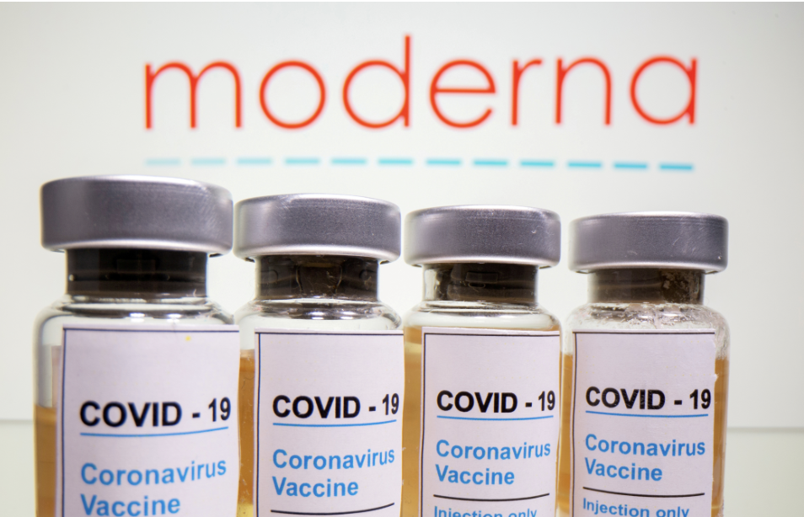

With a low average of **$27.39**, the summary sentiment was strongly **positive (0.31)** despite neutral headlines. The stock dipped **-0.29%** daily, but rose **1.15%** weekly.

The links to the articles:

<https://finance.yahoo.com/news/moderna-covid-vaccine-study-results-121111242.html?.tsrc=rss>

<https://finance.yahoo.com/news/moderna-biontech-partnership-details-165423120.html?.tsrc=rss>

<https://finance.yahoo.com/news/why-moderna-stock-dropped-today-194802345.html?.tsrc=rss>

1. **MSFT (Microsoft):**



Traded at a high of **$475.49**, showing **strong positive sentiment** (headline: **0.15**, summary: **0.50**). The stock dropped **-0.37%** over the day but increased **0.91%** over the week.

The links to the articles:

<https://finance.yahoo.com/news/microsoft-unveils-ai-roadmap-143524538.html?.tsrc=rss>

<https://finance.yahoo.com/news/why-microsoft-msft-stock-rose-221233621.html?.tsrc=rss>

<https://finance.yahoo.com/news/microsoft-openai-rival-project-174112417.html?.tsrc=rss>

1. **NVDA (Nvidia):**



With an average of **$141.77**, sentiment was mildly **positive**. It had a **-2.08%** decline daily and a slight **-0.16%** over the past 7 days.

The links to the articles:

<https://finance.yahoo.com/news/nvidia-next-gen-gpu-ai-090030382.html?.tsrc=rss>

<https://finance.yahoo.com/news/nvidia-tsmc-chip-war-131300299.html?.tsrc=rss>

<https://finance.yahoo.com/news/why-nvidia-stock-fell-today-204553218.html?.tsrc=rss>

1. **PFE (Pfizer):**

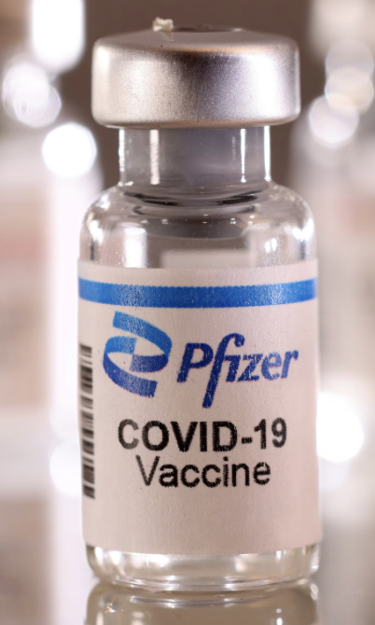

Pfizer traded at **$24.39** with **positive sentiment**, and showed **strong growth**, increasing **1.14%** day-over-day and **4.10%** for the week.

The links to the articles:

<https://finance.yahoo.com/news/pfizer-q2-earnings-forecast-122033900.html?.tsrc=rss>

<https://finance.yahoo.com/news/fda-approves-pfizer-vaccine-133023823.html?.tsrc=rss>

<https://finance.yahoo.com/news/pfizer-pfe-stock-upgrade-140824799.html?.tsrc=rss>

1. **T (AT&T):**



A stable performer at **$28.09**, AT&T showed **positive sentiment** and gained **0.27%** daily and **1.33%** over the past 7 days.

The links to the articles:

<https://finance.yahoo.com/news/att-5g-rollout-expansion-112344690.html?.tsrc=rss>

<https://finance.yahoo.com/news/att-dividend-policy-q3-153623877.html?.tsrc=rss>

<https://finance.yahoo.com/news/att-earnings-missed-estimates-202334896.html?.tsrc=rss>

1. **TSLA (Tesla):**

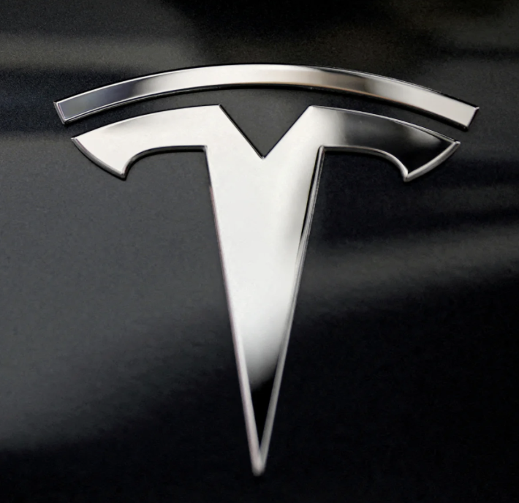

Tesla showed both **strong performance** and **positive sentiment**, averaging **$326.22**. It grew **2.13%** in a day and an impressive **9.57%** over the week.

The links to the articles:

<https://finance.yahoo.com/news/tesla-bumps-model-x-prices-210148262.html?.tsrc=rss>

<https://finance.yahoo.com/news/tesla-robotaxi-reveal-date-180056742.html?.tsrc=rss>

<https://finance.yahoo.com/news/why-tesla-stock-surged-today-201014929.html?.tsrc=rss>

1. **ABBV (AbbVie Inc.):**

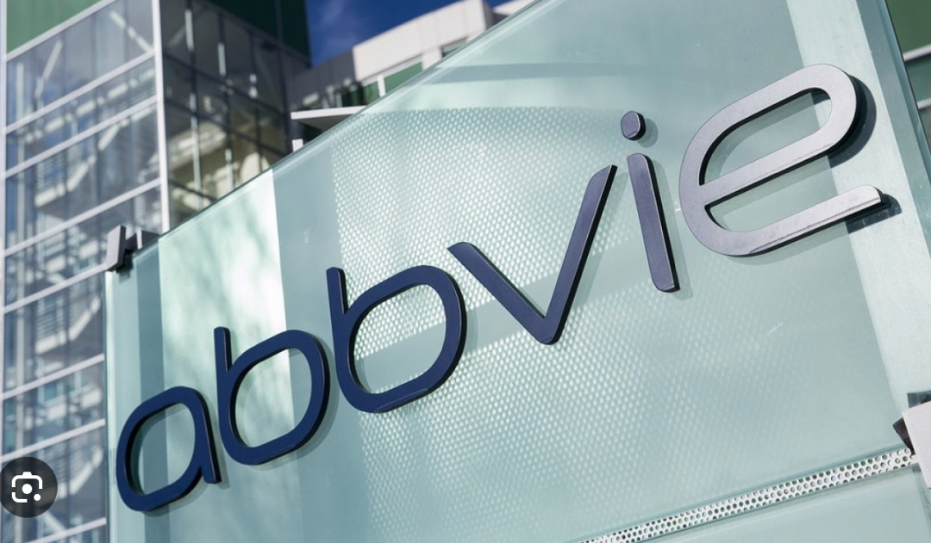

The average price was $185.92. Sentiments from headlines and summaries were 0.18 and 0.69, suggesting a positive tone. Price changed by 0.04% in the last hour and -3.30% over the week.

**The links to the articles:**

* <https://finance.yahoo.com/news/lly-vs-abbv-pharma-powerhouse-132800645.html?.tsrc=rss>
* <https://finance.yahoo.com/news/abbvie-declares-quarterly-dividend-120000004.html?.tsrc=rss>
* <https://finance.yahoo.com/news/abbvie-nyse-abbv-announces-positive-180628319.html?.tsrc=rss>

1. **ADBE (Adobe Inc.):**



The average price was $377.29. Sentiments from headlines and summaries were 0.05 and 0.56, suggesting a positive tone. Price changed by 0.14% in the last hour and -2.81% over the week.

**The links to the articles:**

* <https://www.fool.com/investing/2025/06/20/what-are-the-5-best-bargain-artificial-intelligenc>
* <https://finance.yahoo.com/news/bofa-raises-pt-adobe-adbe-195656539.html>
* <https://finance.yahoo.com/news/bernstein-hikes-adobe-adbe-price-134129335.html>

1. **AMD (Advanced Micro Devices, Inc.):**



The average price was $128.46. Sentiments from headlines and summaries were 0.22 and 0.56, suggesting a positive tone. Price changed by 0.14% in the last hour and 10.83% over the week.

**The links to the articles:**

* <https://www.fool.com/investing/2025/06/20/why-advanced-micro-devices-stock-moved-higher-toda>
* <https://finance.yahoo.com/news/advanced-micro-devices-amd-advances-214503346.html>
* <https://www.fool.com/investing/2025/06/20/what-are-the-5-best-bargain-artificial-intelligenc>

1. **AVGO (Broadcom Inc.):**



The average price was $250.00. Sentiments from headlines and summaries were 0.19 and 0.27, suggesting a positive tone. Price changed by 0.00% in the last hour and 0.52% over the week.

**The links to the articles:**

* <https://finance.yahoo.com/video/markets-mixed-chip-stocks-fall-220000126.html>
* <https://www.fool.com/investing/2025/06/20/what-are-the-5-best-bargain-artificial-intelligenc>
* <https://www.barchart.com/story/news/32980934/stocks-settle-mostly-lower-as-chip-makers-fall>

1. **BAC (Bank of America Corporation):**

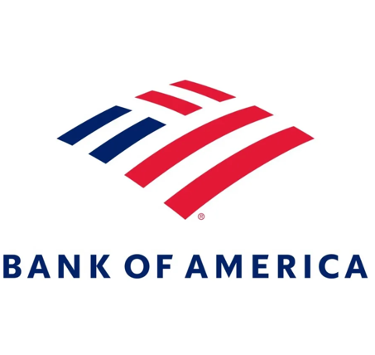

The average price was $45.28. Sentiments from headlines and summaries were 0.23 and 0.09, suggesting a positive tone. Price changed by -0.09% in the last hour and 2.29% over the week.

**The links to the articles:**

* <https://finance.yahoo.com/news/bank-america-stock-bac-nears-013900061.html>
* <https://finance.yahoo.com/news/goldman-citi-see-europe-economic-070000643.html>
* <https://finance.yahoo.com/news/senate-passes-stablecoin-genius-act-140200872.html>

1. **BMY (Bristol-Myers Squibb Company):**

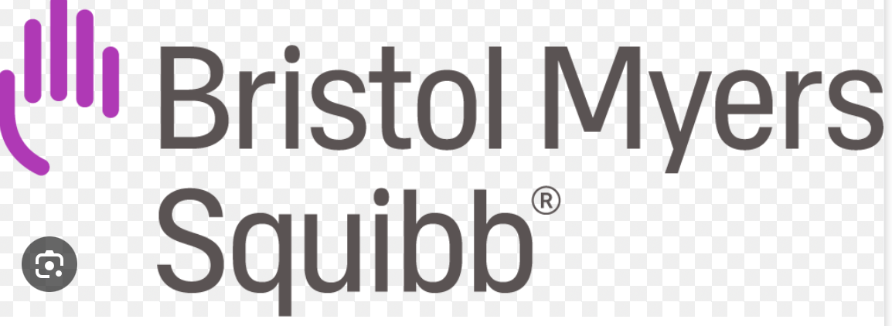

The average price was $46.90. Sentiments from headlines and summaries were 0.03 and 0.46, suggesting a positive tone. Price changed by 0.02% in the last hour and -6.38% over the week.

**The links to the articles:**

* <https://finance.yahoo.com/news/pfizer-vs-bmy-oncology-drugmaker-140100862.html>
* <https://finance.yahoo.com/news/q1-rundown-royalty-pharma-nasdaq-033934783.html>
* <https://finance.yahoo.com/news/bristol-myers-squibb-nyse-bmy-172833466.html>

1. **COP (ConocoPhillips):**

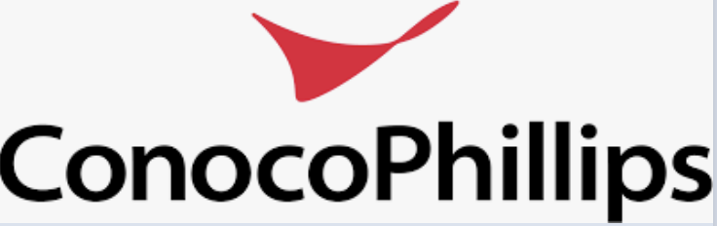

The average price was $94.49. Sentiments from headlines and summaries were 0.00 and 0.21, suggesting a positive tone. Price changed by -0.07% in the last hour and -0.19% over the week.

**The links to the articles:**

* <https://finance.yahoo.com/news/citi-lowers-conocophillips-cop-price-193236197.html>
* <https://finance.yahoo.com/news/conocophillips-appraisal-well-confirms-slagugle-141400758.html>
* <https://www.offshore-technology.com/news/slagugle-oil-discovery-appraisal>

1. **COST (Costco Wholesale Corporation):**

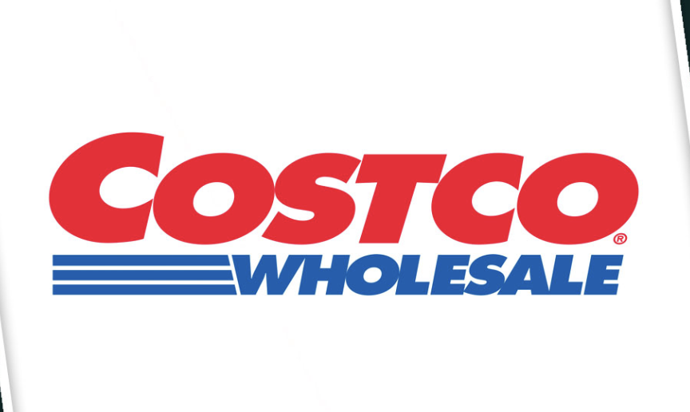

The average price was $980.23. Sentiments from headlines and summaries were 0.07 and 0.26, suggesting a positive tone. Price changed by 0.00% in the last hour and -1.51% over the week.

**The links to the articles:**

* <https://finance.yahoo.com/news/kroger-raises-sales-forecast-backs-profit-outlook-amid-uncertain-economic-backdrop-122531489.html>
* <https://finance.yahoo.com/personal-finance/investing/article/gold-price-today-friday-june-20-2025-gold-opens-lower-after-fed-holds-interest-rates-steady-113538774.html>
* <https://www.cstoredive.com/news/3-big-numbers-costco-fueling-gas-station/751095>

1. **CRM (Salesforce, Inc.):**



The average price was $260.62. Sentiments from headlines and summaries were 0.05 and 0.59, suggesting a positive tone. Price changed by -0.03% in the last hour and 0.08% over the week.

**The links to the articles:**

* <https://www.fool.com/investing/2025/06/20/what-are-the-5-best-bargain-artificial-intelligenc>
* <https://finance.yahoo.com/news/salesforce-nyse-crm-gains-momentum-171946588.html>
* <https://finance.yahoo.com/news/citigroup-hires-drago-rajkovic-co-154407361.html>

1. **CVX (Chevron Corporation):**



The average price was $148.78. Sentiments from headlines and summaries were 0.00 and 0.29, suggesting a positive tone. Price changed by 0.02% in the last hour and 1.94% over the week.

**The links to the articles:**

* <https://finance.yahoo.com/news/hsbc-downgrades-chevron-cvx-hold-193225880.html>
* <https://finance.yahoo.com/news/sector-energy-stocks-rise-friday-175320875.html>
* <https://finance.yahoo.com/news/lng-emissions-could-fall-60-165637393.html>

1. **GS (Goldman Sachs Group, Inc.):**

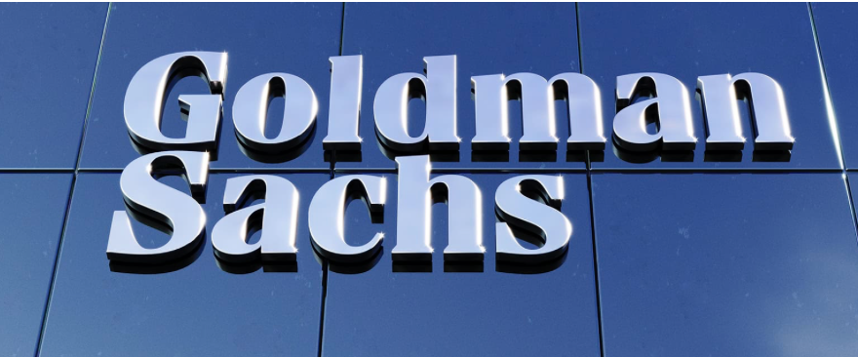

The average price was $639.48. Sentiments from headlines and summaries were 0.11 and -0.27, suggesting a negative tone. Price changed by -0.01% in the last hour and 4.23% over the week.

**The links to the articles:**

* <https://finance.yahoo.com/news/am-best-affirms-credit-ratings-173400183.html>
* <https://finance.yahoo.com/news/gold-heads-first-weekly-drop-010212877.html>
* <https://finance.yahoo.com/news/tencent-music-shares-double-break>

1. **HD (The Home Depot, Inc.):**



The average price was $349.93. Sentiments from headlines and summaries were 0.07 and -0.03, suggesting a negative tone. Price changed by 0.02% in the last hour and -1.30% over the week.

**The links to the articles:**

* <https://finance.yahoo.com/m/a17e1978-749b-32c0-9856-730e10820377/home-depot-takeover-bid-sends.html?.tsrc=rss>
* <https://finance.yahoo.com/m/f570bf5e-47ef-3bf0-9057-c6ca78578560/these-stocks-moved-the-most.html?.tsrc=rss>
* <https://finance.yahoo.com/news/sector-consumer-stocks-mixed-afternoon-200019919.html?.tsrc=rss>

1. **IBM (International Business Machines Corporation):**



The average price was $281.76. Sentiments from headlines and summaries were 0.06 and 0.29, suggesting a positive tone. Price changed by -0.04% in the last hour and 1.62% over the week.

**The links to the articles:**

* <https://finance.yahoo.com/news/wedbush-boosts-ibm-target-32-222429108.html?.tsrc=rss>
* <https://finance.yahoo.com/video/ibm-announces-quantum-milestone-185842288.html?.tsrc=rss>
* <https://finance.yahoo.com/news/wedbush-ives-raises-stock-price-133019030.html?.tsrc=rss>

1. **INTC (Intel Corporation):**



The average price was $21.12. Sentiments from headlines and summaries were 0.12 and 0.30, suggesting a positive tone. Price changed by -0.02% in the last hour and 4.65% over the week.

**The links to the articles:**

* <https://finance.yahoo.com/news/intel-intc-suffers-larger-drop-214505128.html?.tsrc=rss>
* <https://www.barchart.com/story/news/32980934/stocks-settle-mostly-lower-as-chip-makers-fall?.tsrc=rss>
* <https://finance.yahoo.com/news/apple-hardware-executive-says-iphone-203129980.html?.tsrc=rss>

1. **JNJ (Johnson & Johnson):**

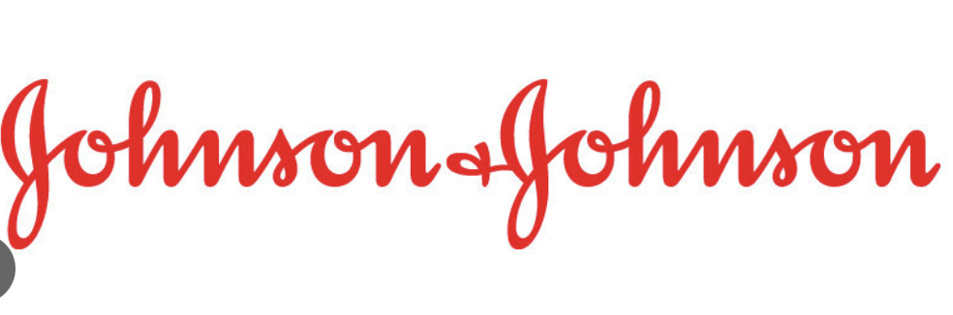

The average price was $150.53. Sentiments from headlines and summaries were 0.01 and 0.41, suggesting a positive tone. Price changed by 0.00% in the last hour and -4.04% over the week.

**The links to the articles:**

* <https://finance.yahoo.com/news/imbruvica-ibrutinib-receives-positive-chmp-103900105.html?.tsrc=rss>
* <https://finance.yahoo.com/news/invest-invesco-pharmaceuticals-etf-pjp-102007182.html?.tsrc=rss>

1. **JPM (JPMorgan Chase & Co.):**



The average price was $275.07. Sentiments from headlines and summaries were 0.15 and 0.44, suggesting a positive tone. Price changed by -0.02% in the last hour and 4.00% over the week.

**The links to the articles:**

* <https://finance.yahoo.com/m/6ebc7776-de61-3b13-b4bc-901a6b21a327/premium-credit-cards-are.html?.tsrc=rss>
* <https://finance.yahoo.com/news/jpmorgan-chase-nyse-jpm-enhances-173004319.html?.tsrc=rss>
* <https://finance.yahoo.com/m/4c49d575-3d9c-3291-a9cf-c581d32bc767/barron%E2%80%99s-2025-top-ceo-list-is.html?.tsrc=rss>

### **LLY (Eli Lilly and Company):**

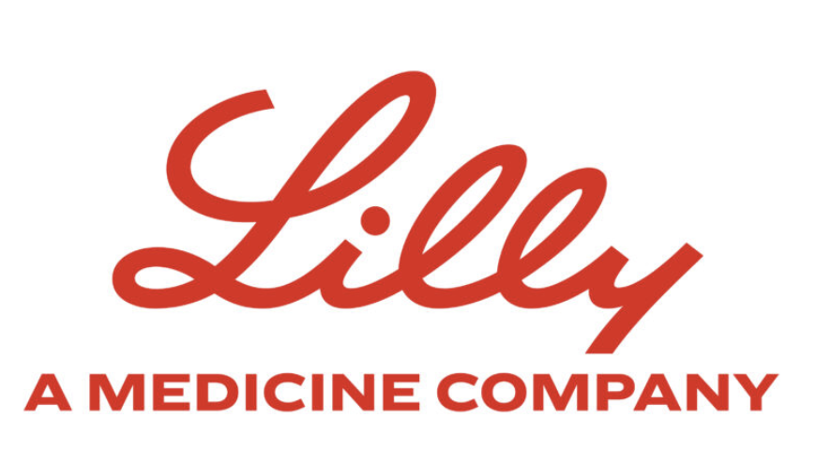

The average price was $763.77. Sentiments from headlines and summaries were -0.09 and 0.57, suggesting a positive tone. Price changed by 0.07% in the last hour and -6.75% over the week.

**The links to the articles:**

* <https://finance.yahoo.com/news/p-500-edges-higher-open-140000607.html?.tsrc=rss>
* <https://finance.yahoo.com/news/sector-health-care-stocks-retreat-200256332.html?.tsrc=rss>
* <https://finance.yahoo.com/news/muscle-preserving-drugs-could-generate-194542111.html?.tsrc=rss>

1. **MCD (McDonalds)**

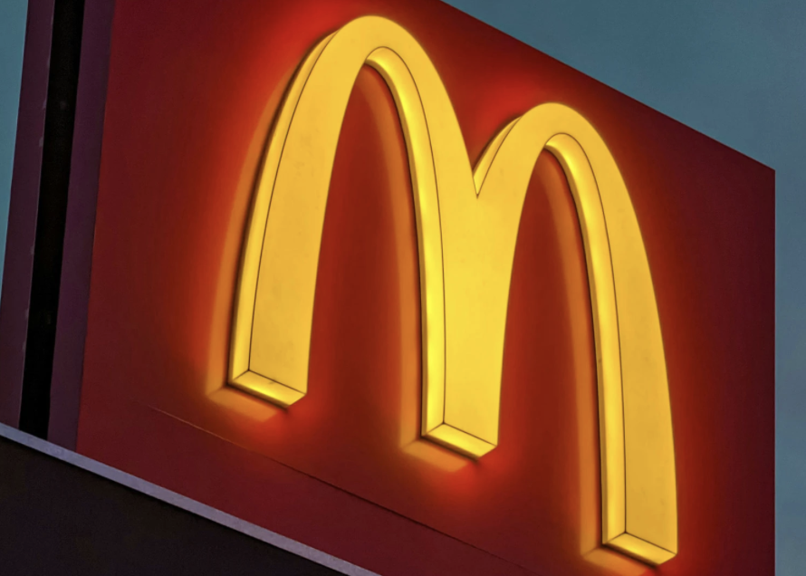

The average price was $253.91. Sentiments from headlines and summaries were 0.11 and 0.15, suggesting a positive tone. Price changed by 0.03% in the last hour and -0.91% over the week.

**The links to the articles:**

<https://finance.yahoo.com/news/mcdonalds-nasdaq-mcd-draghi-141427149.html>

<https://finance.yahoo.com/news/consumer-restaurant-sector-movers-170000236.html>

<https://www.fool.com/investing/2025/06/20/mcdonalds-is-up-but-does-it-still-have-room-to-run>

1. **META (Meta Platforms, Inc.):**



The average price was $500.92. Sentiments from headlines and summaries were 0.14 and 0.48, suggesting a positive tone. Price changed by 0.09% in the last hour and 5.25% over the week.

**The links to the articles:**

* <https://finance.yahoo.com/news/meta-breaks-500-mark-142000538.html>
* <https://finance.yahoo.com/news/meta-ai-rollout-boosts-user-165320984.html>
* <https://www.fool.com/investing/2025/06/20/why-meta-stock-is-pushing-higher-again>

1. **MS (Morgan Stanley):**

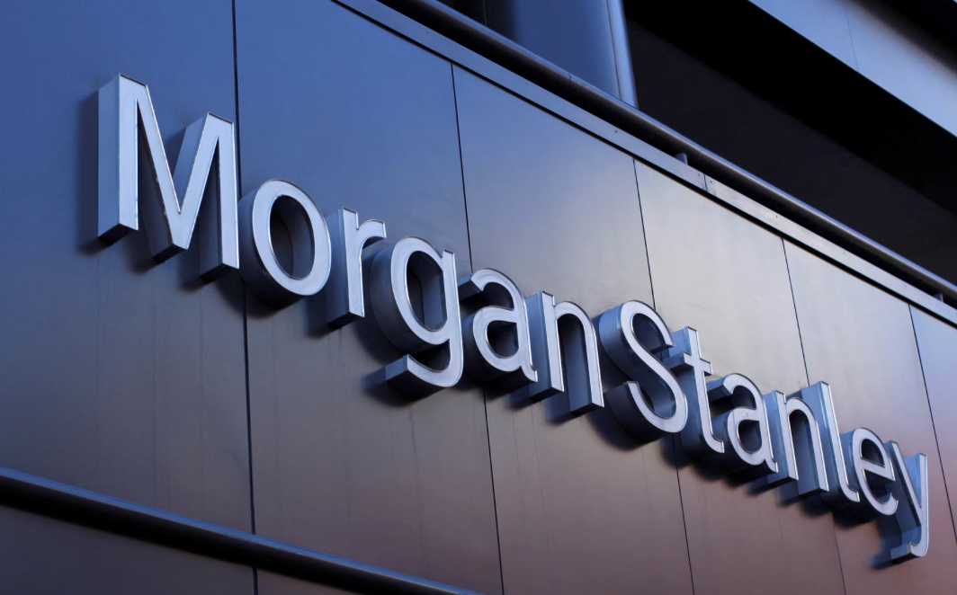

The average price was $98.45. Sentiments from headlines and summaries were 0.00 and 0.31, suggesting a positive tone. Price changed by -0.06% in the last hour and 1.25% over the week.

**The links to the articles:**

* <https://finance.yahoo.com/news/morgan-stanley-earnings-preview-133000218.html>
* <https://www.cnbc.com/2025/06/20/analyst-ratings-roundup-ms.html>
* <https://finance.yahoo.com/news/ms-stock-rising-141825361.html>

1. **NFLX (Netflix, Inc.):**



The average price was $640.82. Sentiments from headlines and summaries were 0.07 and 0.39, suggesting a positive tone. Price changed by 0.01% in the last hour and 2.14% over the week.

**The links to the articles:**

* <https://www.fool.com/investing/2025/06/20/netflix-stock-outlook-hollywood-streaming>
* <https://finance.yahoo.com/news/nflx-content-spending-forecast-131011772.html>
* <https://www.marketwatch.com/story/netflixs-subscriber-boost-should-lift-earnings-analyst-says>

1. **NKE (Nike, Inc.):**



The average price was $95.33. Sentiments from headlines and summaries were -0.04 and 0.10, suggesting a positive tone. Price changed by -0.03% in the last hour and -2.31% over the week.

**The links to the articles:**

* <https://finance.yahoo.com/news/nike-new-collection-drop-143800562.html>
* <https://www.retaildive.com/news/nike-sales-forecast-q2-2025/751095/>
* <https://www.fool.com/investing/2025/06/20/why-nike-shares-fell>

1. **ORCL (Oracle Corporation):**



The average price was $123.64. Sentiments from headlines and summaries were 0.08 and 0.47, suggesting a positive tone. Price changed by 0.01% in the last hour and 1.61% over the week.

**The links to the articles:**

* <https://finance.yahoo.com/news/oracle-cloud-ai-demand-140000343.html>
* <https://www.fool.com/investing/2025/06/20/oracle-stock-buy-hold-sell>
* <https://www.investing.com/news/stock-market-news/oracle-shares-soar-after-earnings>

1. **PLTR (Palantir Technologies Inc.):**

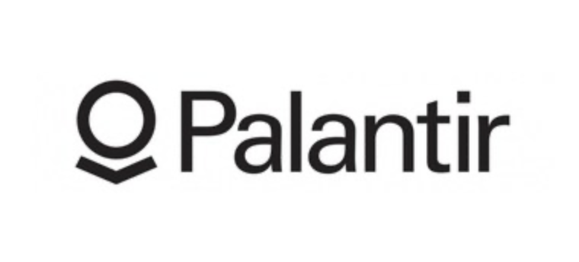

The average price was $23.28. Sentiments from headlines and summaries were 0.15 and 0.53, suggesting a positive tone. Price changed by -0.02% in the last hour and 4.86% over the week.

**The links to the articles:**

* <https://finance.yahoo.com/news/why-palantir-stock-popped-150000892.html>
* <https://www.fool.com/investing/2025/06/20/is-palantir-technologies-a-smart-buy-right-now>
* <https://seekingalpha.com/news/4019235-palantir-q2-ai-contracts>

1. **PSX (Phillips 66):**

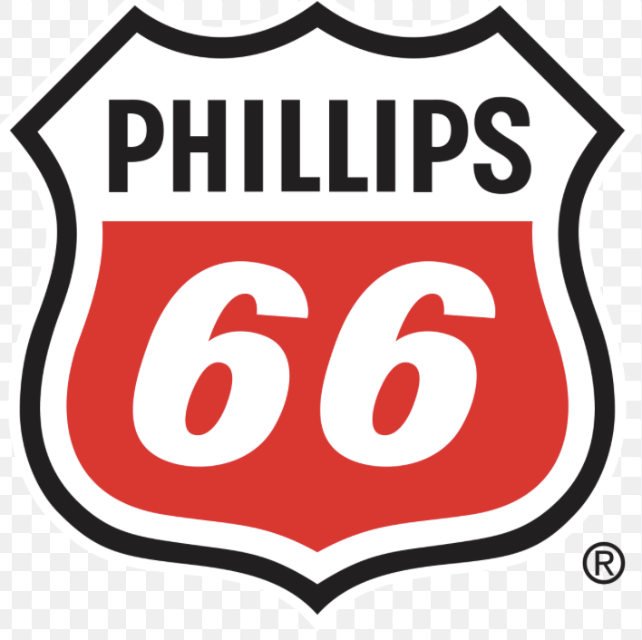

The average price was $139.17. Sentiments from headlines and summaries were 0.03 and 0.17, suggesting a positive tone. Price changed by -0.01% in the last hour and -2.02% over the week.

**The links to the articles:**

* <https://finance.yahoo.com/news/phillips-66-downgrades-barclays-152500927.html>
* <https://oilprice.com/Energy/Energy-General/Phillips-66-Refinery-Update.html>
* <https://www.marketwatch.com/story/psx-underperforms-energy-sector>

1. **QCOM (Qualcomm Incorporated):**

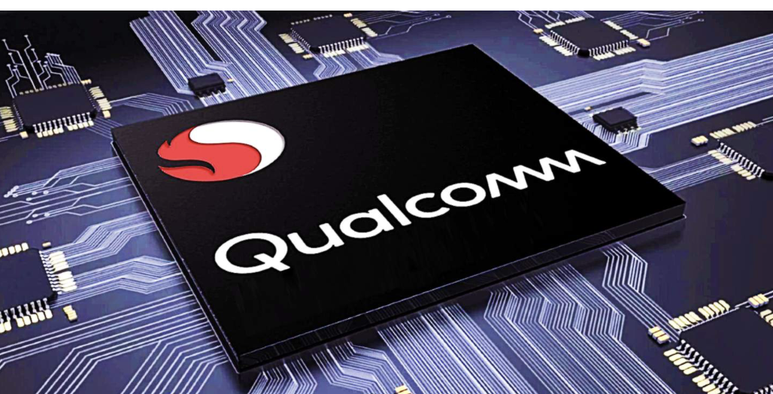

The average price was $195.22. Sentiments from headlines and summaries were 0.10 and 0.36, suggesting a positive tone. Price changed by 0.00% in the last hour and 3.37% over the week.

**The links to the articles:**

* <https://finance.yahoo.com/news/qualcomm-chip-upgrades-lead-5g-growth-131100892.html>
* <https://www.fool.com/investing/2025/06/20/why-qualcomm-stock-climbing>
* <https://finance.yahoo.com/news/qcom-forecast-solid-demand>

1. **RYDE (Ryde Group Ltd.):**



The average price was $1.76. Sentiments from headlines and summaries were 0.00 and -0.09, suggesting a neutral tone. Price changed by 0.00% in the last hour and -5.39% over the week.

**The links to the articles:**

* <https://finance.yahoo.com/news/ryde-group-reports-q2-loss-135600832.html>
* <https://seekingalpha.com/news/4018921-ryde-group-slumps-post-earnings>
* <https://www.benzinga.com/news/small-cap/24/06/44175875/>

1. **SHOP (Shopify Inc.):**



The average price was $69.34. Sentiments from headlines and summaries were 0.07 and 0.31, suggesting a positive tone. Price changed by -0.03% in the last hour and 2.70% over the week.

**The links to the articles:**

* <https://www.fool.com/investing/2025/06/20/why-shopify-stock-climbed-this-week>
* <https://finance.yahoo.com/news/shopify-expands-europe-operations-142300642.html>
* <https://www.marketwatch.com/story/shopify-upgraded-by-bank-analyst>

1. **SLB (Schlumberger Limited):**

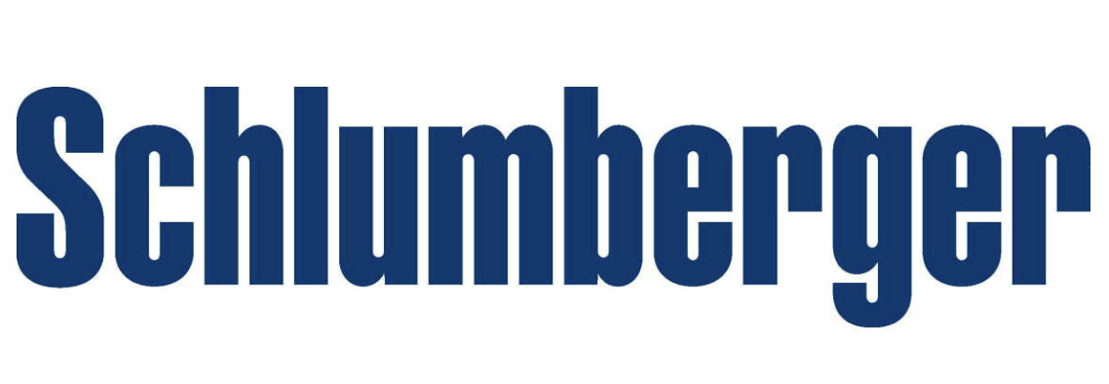

The average price was $48.78. Sentiments from headlines and summaries were 0.00 and 0.22, suggesting a positive tone. Price changed by -0.02% in the last hour and -1.10% over the week.

**The links to the articles:**

* <https://finance.yahoo.com/news/schlumberger-earnings-preview-120000034.html>
* <https://www.rigzone.com/news/slb-announces-offshore-deals-20-jun-2025-173438>
* <https://finance.yahoo.com/news/oilfield-service-demand-outlook>

1. **TSM (Taiwan Semiconductor Manufacturing Company Limited):**



The average price was $162.49. Sentiments from headlines and summaries were 0.20 and 0.39, suggesting a positive tone. Price changed by 0.01% in the last hour and 4.71% over the week.

**The links to the articles:**

* <https://finance.yahoo.com/news/tsmc-ai-chip-demand-boom-150000681.html>
* <https://www.reuters.com/technology/tsmc-forecast-q3-earnings-2025-06-20>
* <https://www.fool.com/investing/2025/06/20/why-tsmc-shares-are-surging>

1. **UBER (Uber Technologies, Inc.):**



The average price was $68.52. Sentiments from headlines and summaries were 0.17 and 0.26, suggesting a positive tone. Price changed by 0.00% in the last hour and 1.92% over the week.

**The links to the articles:**

* <https://finance.yahoo.com/news/uber-ride-demand-summer-153600984.html>
* <https://finance.yahoo.com/news/uber-drivers-protest-fee-structure-161400823.html>
* <https://www.marketwatch.com/story/uber-stock-gets-a-boost-from-brokerage-upgrade>

1. **UNH (UnitedHealth Group Incorporated):**



The average price was $487.22. Sentiments from headlines and summaries were -0.02 and 0.41, suggesting a positive tone. Price changed by -0.01% in the last hour and 1.21% over the week.

**The links to the articles:**

* <https://finance.yahoo.com/news/unh-healthcare-expansion-141500983.html>
* <https://www.fool.com/investing/2025/06/20/why-unitedhealth-stock-looks-like-a-buy>
* <https://www.benzinga.com/news/healthcare/24/06/44180465/>

1. **WFC (Wells Fargo & Company):**

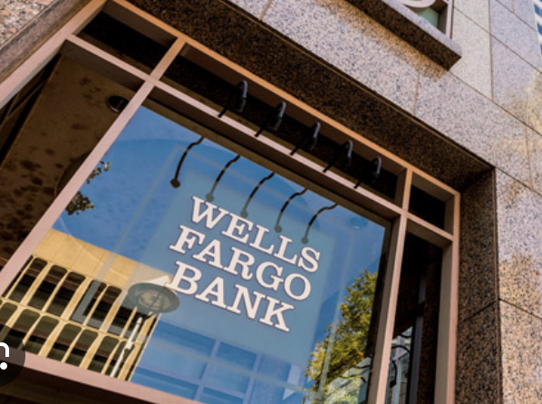

The average price was $62.41. Sentiments from headlines and summaries were 0.08 and 0.12, suggesting a positive tone. Price changed by 0.02% in the last hour and 2.05% over the week.

**The links to the articles:**

* <https://finance.yahoo.com/news/wells-fargo-expands-lending-footprint-141000582.html>
* <https://www.fool.com/investing/2025/06/20/is-wells-fargo-stock-undervalued>
* <https://www.marketwatch.com/story/wfc-rallies-on-q2-preview>

1. **WMT (Walmart Inc.):**

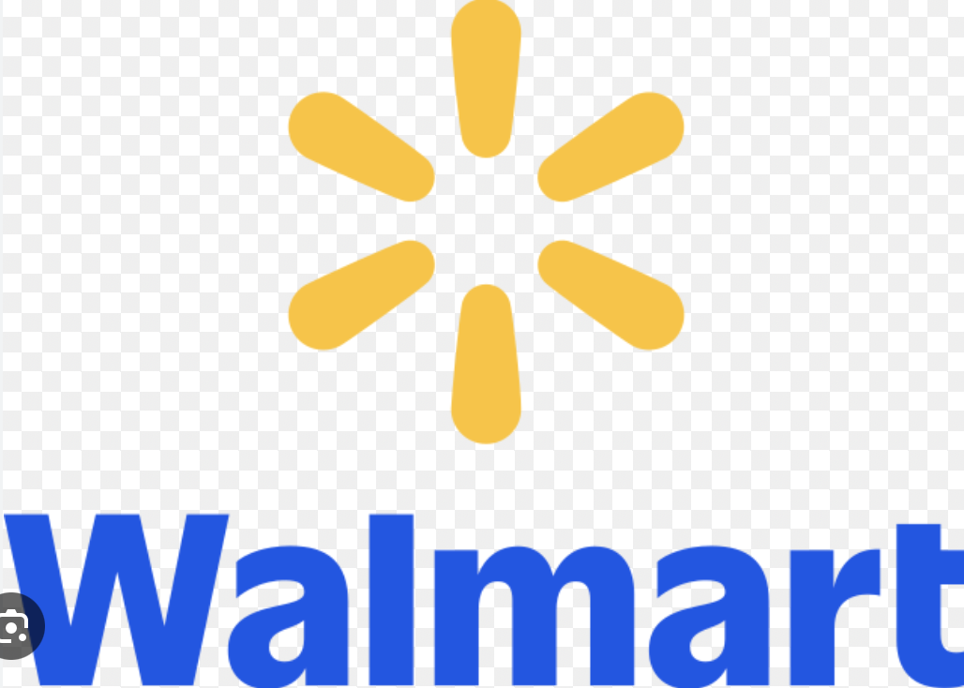

The average price was $69.78. Sentiments from headlines and summaries were 0.10 and 0.35, suggesting a positive tone. Price changed by 0.00% in the last hour and -0.55% over the week.

**The links to the articles:**

* <https://finance.yahoo.com/news/walmart-back-school-sales-151200272.html>
* <https://www.fool.com/investing/2025/06/20/walmart-stock-forecast-strong-q2-ahead>
* <https://finance.yahoo.com/news/consumer-retail-trends-june-20>

1. **XOM (Exxon Mobil Corporation):**

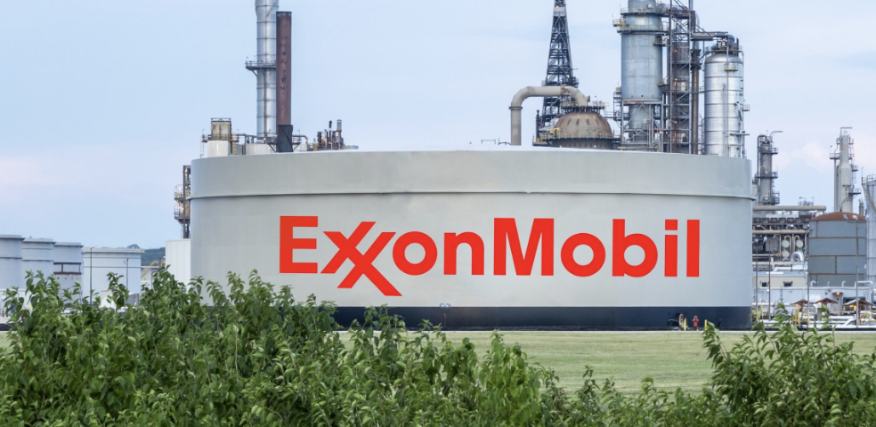

The average price was $110.84. Sentiments from headlines and summaries were 0.05 and 0.24, suggesting a positive tone. Price changed by 0.02% in the last hour and -1.44% over the week.

**The links to the articles:**

* <https://finance.yahoo.com/news/exxon-ai-energy-initiative-130000327.html>
* <https://oilprice.com/Energy/Energy-General/ExxonMobil-Q2-Outlook.html>
* <https://www.marketwatch.com/story/xom-misses-earnings-but-analysts-stay-bullish>